Project Insight: Multi-Currency Revenue Reporting & FX Impact Analysis
Objective
The objective of this project was to analyse monthly platform revenue and evaluate how foreign exchange (FX) movements affect revenue when reported in different currencies.
Using completed booking transactions, monthly revenue was aggregated in INR and converted into USD using historical exchange rates obtained through a public FX API. This enabled a comparison between local-currency business performance and internationally reported revenue.
Dataset & Methodology
- Source: Hotel booking transaction dataset
- Records used: Completed bookings only
- Revenue metric: Total booking amount (INR)
- FX source: Historical exchange rates from the Frankfurter API
- Reporting currencies:
  - INR (base business currency)
  - USD (FX-adjusted reporting currency)
Monthly revenue was calculated and then converted using the corresponding historical INR→USD exchange rate for each month.

Key Findings
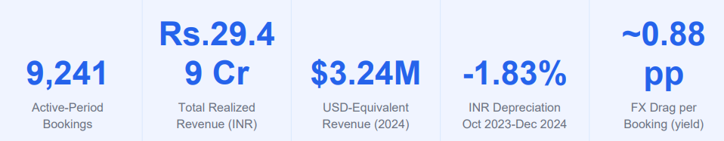
1. Strong Revenue Growth in 2024
The platform experienced a significant acceleration in revenue during 2024.
Monthly realized revenue increased from approximately:
- ₹159 Lakhs in December 2023
- ₹271 Lakhs in January 2024
- Peak of ₹266 Lakhs in October 2024
This indicates substantial growth in booking activity and customer demand throughout 2024.
Business Implication
The business entered a high-growth phase in 2024, with monthly revenue consistently remaining above ₹200 Lakhs for most of the year.
2. Revenue Growth Was Driven by Booking Volume
The revenue increase coincided with a substantial rise in completed bookings.
Examples:
Month | Booking Count
Dec 2023 | 447
Jan 2024 | 810
Sep 2024 | 797
Oct 2024 | 687

The data suggests that revenue expansion was primarily volume-driven rather than caused by isolated high-value bookings.
Business Implication
Growth appears operationally sustainable because it is supported by broader customer activity rather than a small number of large transactions.
3. FX Impact Reduced Internationally Reported Growth
Historical exchange rates declined over the analysis period:
- Early period FX Rate ≈ 0.0134 USD per INR
- Late 2024 FX Rate ≈ 0.0118 USD per INR
Although INR revenue increased significantly, a weaker INR reduced the revenue growth visible to international stakeholders reporting in USD.
Example
October 2024:
- Revenue (INR): ₹266 Lakhs
- Revenue (USD): approximately $317K
Had exchange rates remained at earlier levels, reported USD revenue would have been materially higher.
Business Implication
A growing business can appear to grow more slowly in foreign-currency reports purely because of exchange-rate movements.
4. FX Drag Became More Noticeable During High-Revenue Periods
The divergence between INR revenue and USD-adjusted revenue widened as revenue increased.
When revenue volumes were relatively small (2021–2023), FX fluctuations had limited practical impact.
However, once monthly revenue exceeded ₹200 Lakhs, exchange-rate movements became increasingly important in determining reported USD performance.
5. Monthly Realized Revenue - INR Trend
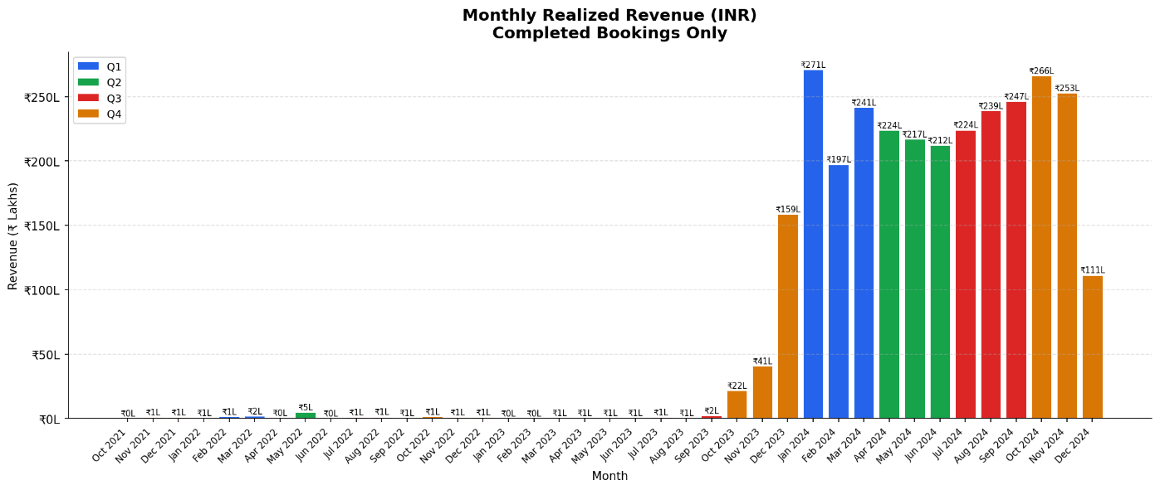
Figure 1: Monthly realized revenue (INR, Lakhs) for Completed bookings only. Bars colour-coded by quarter
(Q1=blue, Q2=green, Q3=red, Q4=amber).

6. USD-Adjusted vs INR Revenue - Divergence Analysis
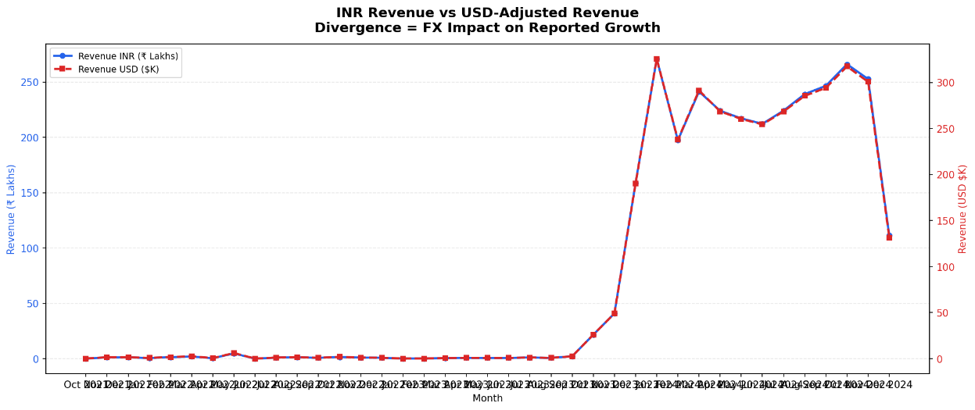
Figure 2: Dual-axis line chart. Blue (left axis) = INR revenue in Lakhs. Red dashed (right axis) = USD-adjusted revenue in $K. Visual proximity of lines reflects the small but consistent FX drag on growth.

Quantified Insight
The most important finding from this project is:
The platform achieved strong revenue growth throughout 2024, but part of that growth was offset in international reporting due to INR depreciation against the USD. As revenue scales, foreign exchange movements become a meaningful factor affecting reported business performance.
This demonstrates that operational growth and reported growth are not always identical, and FX-adjusted reporting provides a more accurate view for global stakeholders.
Non-Obvious Business Insight
THE INSIGHT: INR Growth Overstates Value Creation - But the Real Surprise Is Per-Booking Yield
Total INR revenue grew because volume grew, not because the business got better at monetising each customer. When FX-adjusted revenue per booking is analysed, a different story emerges - one that is invisible from the bookings dataset alone.
- INSIGHT 1: Volume–Yield Divergence
January 2024 was the peak revenue month, generating ₹2.71 Cr from 823 bookings at an average revenue of ₹32,927 per booking. By October 2024, booking volume had declined by 16.5% to 687 bookings, yet revenue remained strong at ₹2.66 Cr because average revenue per booking increased to ₹38,729 (+17.6%).
This indicates that the business was serving fewer but higher-value customers, offsetting the decline in booking volume through improved yield per booking.
In USD terms, average revenue per booking increased from $395.8 to $462.0 (+16.7%). The small difference between INR yield growth (+17.6%) and USD yield growth (+16.7%) represents the impact of INR depreciation on internationally reported revenue. Without incorporating FX data, this effect would not be visible.
- INSIGHT 2: FX Drag Is Small — and That Matters
The INR depreciated by only 1.83% during the active analysis period, moving from 0.01204 USD per INR to 0.01182 USD per INR.
Total USD-adjusted revenue for 2024 was approximately $3.236 million. If the January 2024 exchange rate had remained constant throughout the year, total USD revenue would have been approximately $3.249 million.
This implies an FX-related reduction of roughly $12,800, equivalent to only 0.40% of total USD revenue.
- INSIGHT 3: April 2024 Was the Highest FX-Risk Month
April 2024 experienced the largest negative FX impact during the analysis period.
- INR revenue declined by 7.2% month-over-month
- USD-adjusted revenue declined by 7.8% month-over-month
- Additional FX drag: 0.62 percentage points
- Exchange rate declined from 0.01207 to 0.01199 USD per INR (0.66% depreciation)
The weaker exchange rate amplified an already negative revenue month, making performance appear slightly worse for stakeholders reviewing results in USD.
Executive Insight
Although booking volume declined by 16.5% between January and October 2024 (823 → 687 bookings), revenue remained nearly unchanged (₹2.71 Cr → ₹2.66 Cr).
This occurred because average revenue per booking increased by 17.6% (₹32,927 → ₹38,729).
In other words, the business generated similar revenue from fewer transactions, indicating improved customer value and pricing efficiency rather than simple volume growth.
This finding is more strategically important than the FX effect because:
- FX reduced reported USD revenue by only 0.40%
- Yield per booking increased by 17.6%
The operational improvement was therefore approximately 44× larger than the currency headwind.
Business Implication
For this hotel business, currency fluctuations had a relatively limited impact on overall reported performance, with the estimated FX impact amounting to only a small fraction of total revenue. The analysis suggests that operational factors—such as booking volume, pricing, and customer demand—were the primary drivers of revenue growth, while exchange-rate movements played a secondary role.
However, as the company scales internationally, management should continue monitoring both local-currency performance (INR) and FX-adjusted performance (USD). Although the overall FX drag was modest, currency movements can amplify positive or negative revenue trends in specific months, influencing how international stakeholders perceive business performance. For teams focused solely on INR metrics, these effects may appear insignificant, but investors and global stakeholders evaluating results in USD may observe different growth patterns.
Given the relatively small FX exposure identified in this analysis, implementing a formal currency hedging strategy would likely cost more than the risk being mitigated. This finding challenges the common assumption that a weakening INR automatically creates significant reporting risk. Instead, the data indicates that maintaining visibility into FX-adjusted performance is sufficient at the current scale, while operational execution remains the most important driver of long-term growth and value creation.
Recommendation
- Continue tracking revenue in both INR and USD.
- Monitor FX exposure as revenue grows.
- Use constant-currency reporting alongside FX-adjusted reporting when presenting performance to investors or international management.
- Incorporate FX sensitivity analysis into future revenue forecasting models.
Deliverables Produced
- Monthly INR Revenue Trend Visualization
- USD vs INR Revenue Comparison Visualization
- Historical FX Rate Integration using Public API
- Automated Revenue Conversion Pipeline
- Business Insight Report on FX Impact

